Taste of Art
December 13, 2 pm

Holiday Cards!

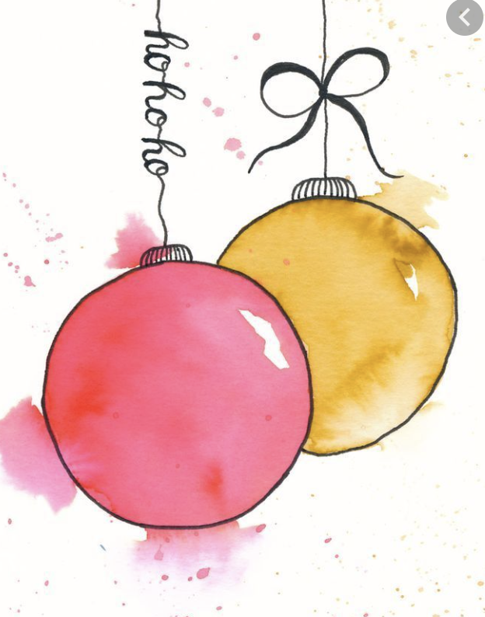

Bring one or two favorite holiday decorations or ornaments to serve as inspiration for Holiday Cards.

We use watercolor to create our own cards (card paper and envelopes provided). All painting supplies included.

SOUTH Community Room

Sponsored by Tidewater Arts Outreach & the VA Beach Art Center

